74 – CAMPUS FESTIVAL REGISTRATION
1. Problem Statement
Reconcile participant registrations, registration fees, sponsorships, and event expenses; detect duplicate registration IDs and calculate the final financial balance.
2. Objectives
Use lists and tuples to represent registrations and expenses.
Validate records and detect duplicates.
Calculate income, expenses, and final balance.
3. Assumptions
Each valid participant pays the same registration fee.
Sponsorships and expenses are entered as non-negative amounts.
Duplicate registration IDs count only once; invalid records are skipped.
4. Algorithm
1. Read registration fee and participant records.
2. Reject empty IDs and detect duplicate IDs.
3. Read sponsorship amounts and expense records.
4. Calculate valid registration income, sponsorship income, total expenses, and final balance.
5. Report duplicate IDs and whether the event has a surplus, deficit, or break-even balance.
5. Flowchart
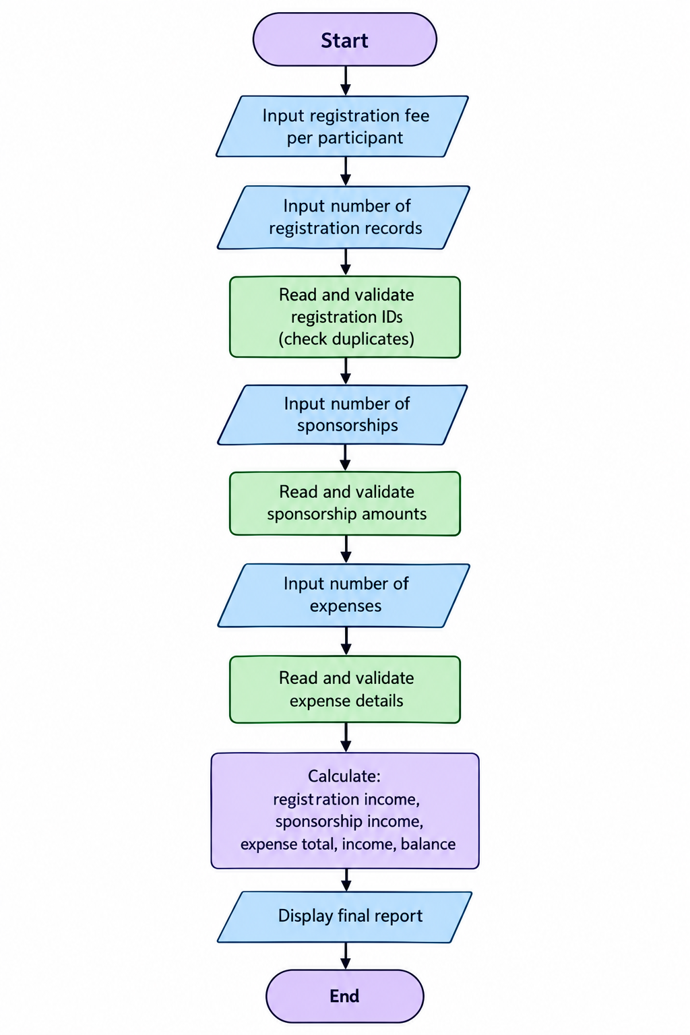
6. Pseudocode
START
INPUT fee, participant count
READ participant IDs; accept unique non-empty IDs only
INPUT sponsorship amounts and expense amounts
registration_income = valid_count * fee
total_income = registration_income + sponsorship_total
balance = total_income - expense_total
IF balance > 0: surplus; ELSE IF balance < 0: deficit; ELSE break-even
PRINT audit
END
7. Test Cases
Test | Input / Scenario | Expected result
1 | fee ₹100; IDs P1,P2,P1; sponsorship ₹500; expenses ₹300 | 2 unique participants; registration income ₹200; total income ₹700; balance ₹400; duplicate P1
2 | no sponsorship and expenses exceed income | Deficit reported
3 | negative expense | Invalid expense rejected
8. Output Screenshot
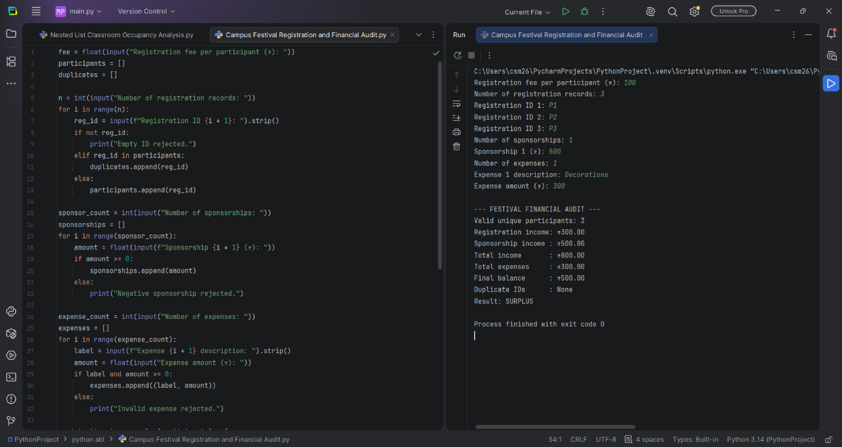
9. Conclusion
The program audits festival finances by counting unique registrations, combining income sources, summing expenses, and reporting the final balance.

